Hilado, Xyleen

Ungos, Carl Marco

**Machine Problem 4**

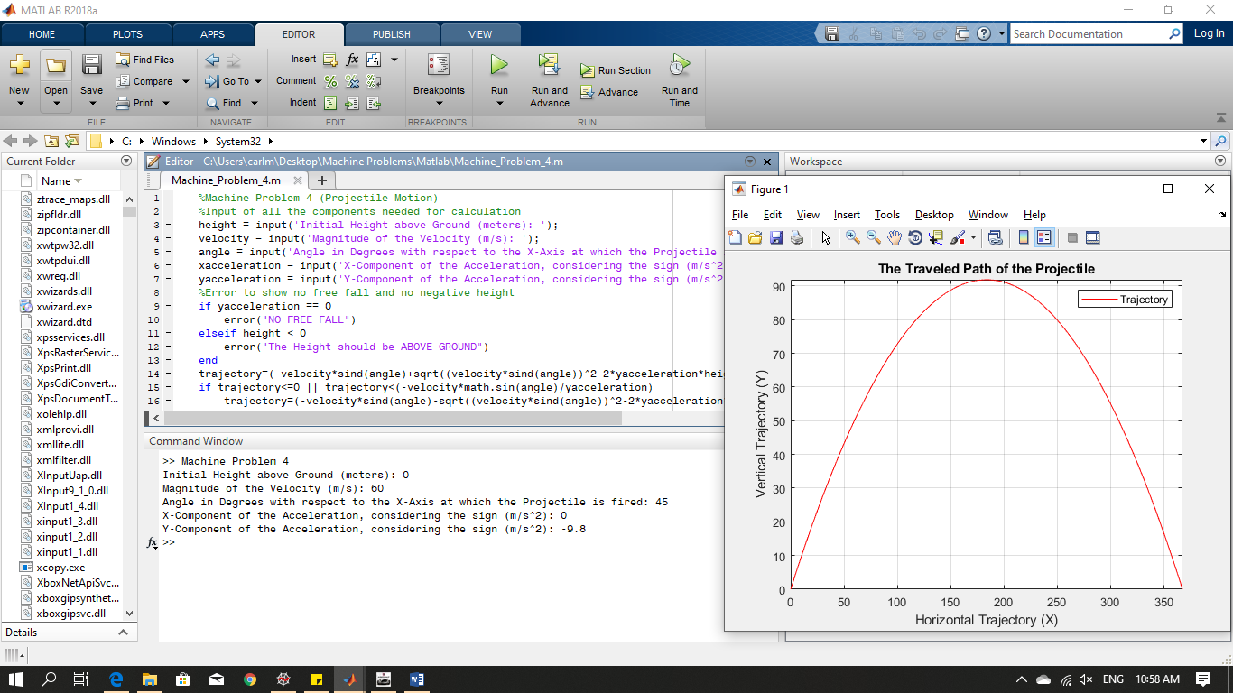

**Graph of the Tested Value**

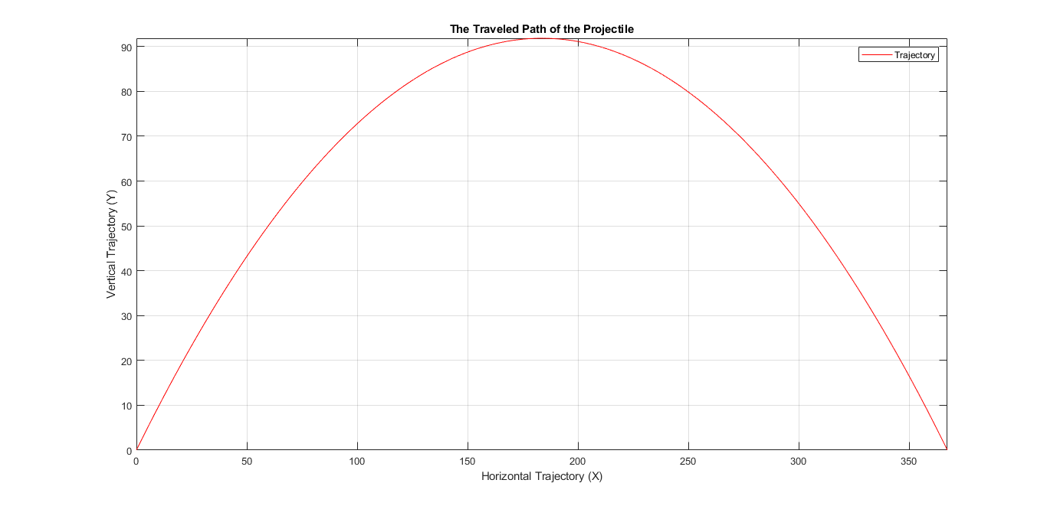

**Height Error**

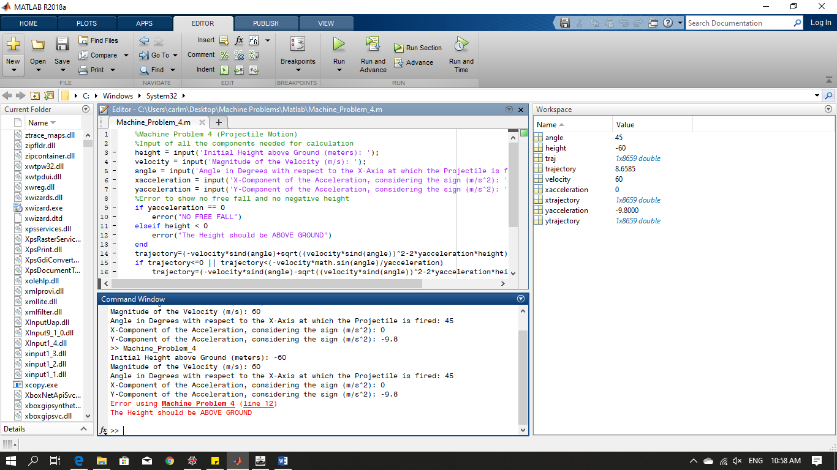

**Y-Component Error**

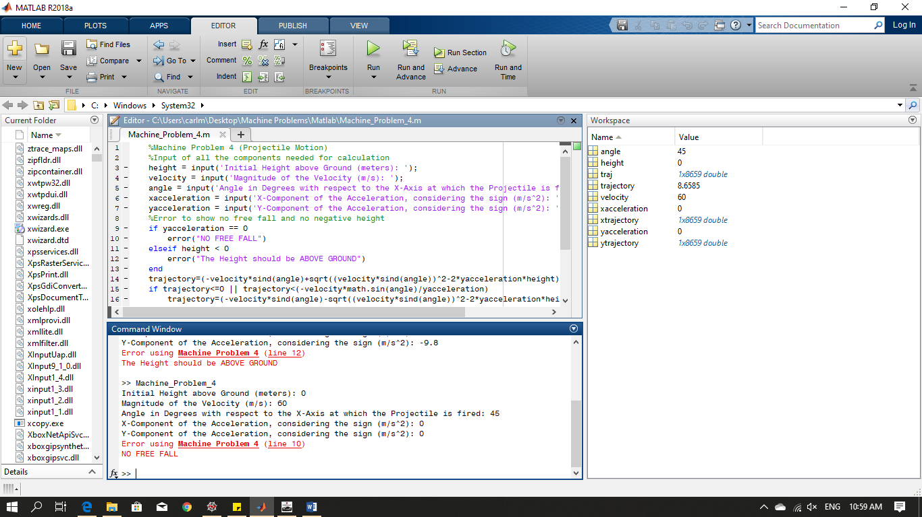

**With X-Component**

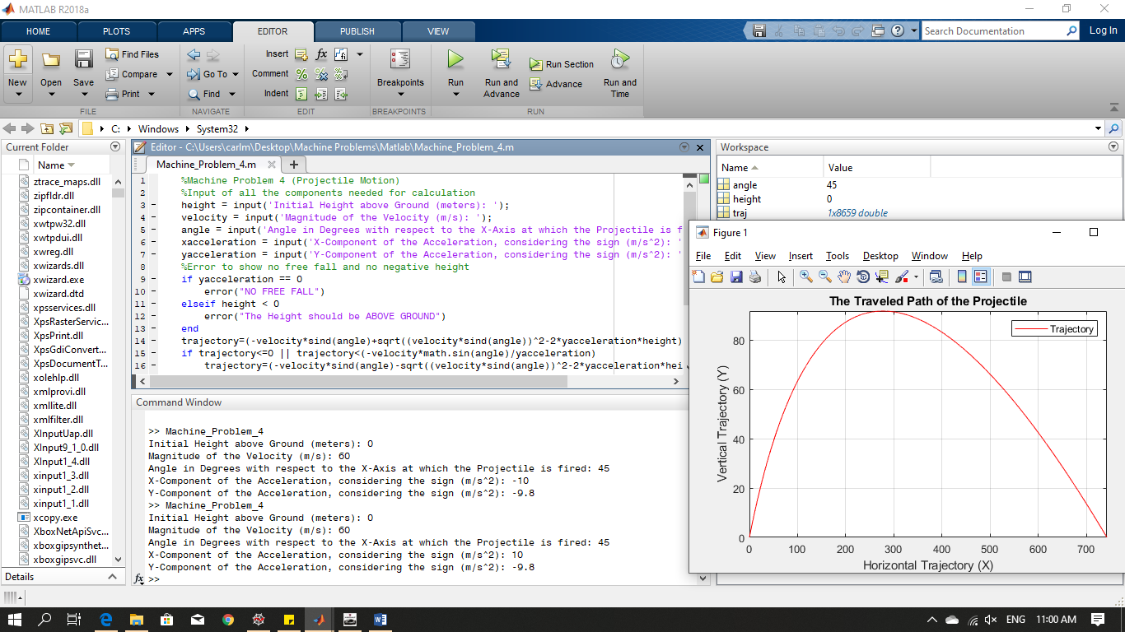

**Graph With X-Component**